Programming Assignment Unit 4

University of the People

CS 2203 Databases 1

Naeem Ahmed, instructor

September 28, 2022

Programming Assignment Unit 4

I designed these relations below for the hospital MS in the previous programming assignment.

|  |  |  |
| --- | --- | --- |
|  | **Doctor Relation** |  |
| **Attributes** | **Description** | **Type** |
| Doctor_ID | It is the primary key of Doctor relation, it should be   * Entity integrity constraint * Null constraint * Unique constraint | Numeric |
| Name | * Null constraint | Text |
| Phone | * Null constraint | Numeric |
| Specialty | * Null constraint | Text |
| Specialty_Num | * Null constraint | Numeric |
| Supervisor_ID | * Null constraint | Numeric |

|  |  |  |
| --- | --- | --- |
|  | **Patient Relation** |  |
| **Attributes** | **Description** | **Type** |
| Patient_ID | It is the primary key of Patient relation, it should be   * Entity integrity constraint * Null constraint * Unique constraint | Numeric |
| Name | * Null constraint | Text |
| Phone | * Null constraint | Numeric |
| Email | * No constraint | Text |
| Address | * Null constraint | Text |
| Added_date | * Null constraint | Date |
| Allergies | * No constraint | Text |
| Doctor_ID | * Null constraint * Referential integrity constraint | Numeric |

|  |  |  |
| --- | --- | --- |
|  | **Appointment Relation** |  |
| **Attributes** | **Description** | **Type** |
| Appointment_ID | It is the primary key of Appointment relation, it should be   * Entity integrity constraint * Null constraint * Unique constraint | Numeric |
| Doctor_ID | * Null constraint * Referential integrity constraint | Numeric |
| Patient_ID | * Null constraint * Referential integrity constraint | Numeric |
| Date | * Null constraint | Date |
| Blood_Pressure | * Null constraint | Numeric |
| Weight | * Null constraint | Numeric |
| Treatment_Notes | * Null constraint | Text |
| Medicines | * No constraint | Text |

1. Let’s define or describe the changes required to get the relations into the 1st normal form.

According to Shahbaz (2015), we know that a relation is in the first normal form if

* The table has a primary key.
* No single column has multiple values.
* The no primary key columns depend on the primary key.

Therefore we have the patient and the appointment relations that have multivalued attributes according to the assignment hint these are allergies, and Medicines respectively. Furthermore, we design tables to contain patient information about allergy and medicine.

|  |  |  |
| --- | --- | --- |
|  | **Allergy Relation** |  |
| **Attributes** | **Description** | **Type** |
| Allergy_ID | It is the primary key of Allergy relation, it should be   * Entity integrity constraint * Null constraint * Unique constraint | Numeric |
| Name | * Null constraint | Text |

|  |  |  |
| --- | --- | --- |
|  | **Patient_Allergy Relation** |  |
| **Attributes** | **Description** | **Type** |
| Allergy_ID | * Entity integrity constraint * Null constraint * Unique constraint * Referential integrity constraint | Numeric |
| Patient_ID | * Entity integrity constraint * Null constraint * Unique constraint * Referential integrity constraint | Numeric |

|  |  |  |
| --- | --- | --- |
|  | **Medicine Relation** |  |
| **Attributes** | **Description** | **Type** |
| Medicine_ID | It is the primary key of Medicine relation, it should be   * Entity integrity constraint * Null constraint * Unique constraint | Numeric |
| Allerrgy_Name | * Null constraint | Text |

|  |  |  |
| --- | --- | --- |
|  | **Patient_Medicine Relation** |  |
| **Attributes** | **Description** | **Type** |
| Appointment_ID | * Entity integrity constraint * Null constraint * Unique constraint * Referential integrity constraint | Numeric |
| Medicine_ID | * Entity integrity constraint * Null constraint * Unique constraint * Referential integrity constraint | Numeric |

1. Let’s define or describe the changes required to get the relations into the 2nd normal form.

We know that a relation is in the second normal form if

* The table satisfies 1NF (first normal form).
* Non-primary key attributes depend on all attributes of a composite key.

Therefore, we don’t have further changes to the 2nd normal form.

1. Let’s define or describe the changes required to get the relations into the 3rd normal form.

We know that a relation is in the third normal form if

* The table meets the criteria for 2NF.
* Each non-primary key attribute in a row does not depend on the entry in another key column.

However, we can make some changes in the Doctor relation because we have a non-primary key that is Specialty_num.

|  |  |  |
| --- | --- | --- |
|  | **Specialty Relation** |  |
| **Attributes** | **Description** | **Type** |
| Specialty_Num | It is the primary key of Specialty relation, it should be   * Entity integrity constraint * Null constraint * Unique constraint | Numeric |
| Name | * Null constraint | Text |

Finally, as requested by the assignment the Entity-Relationship (ER) Diagram for the third normal form is shown below.

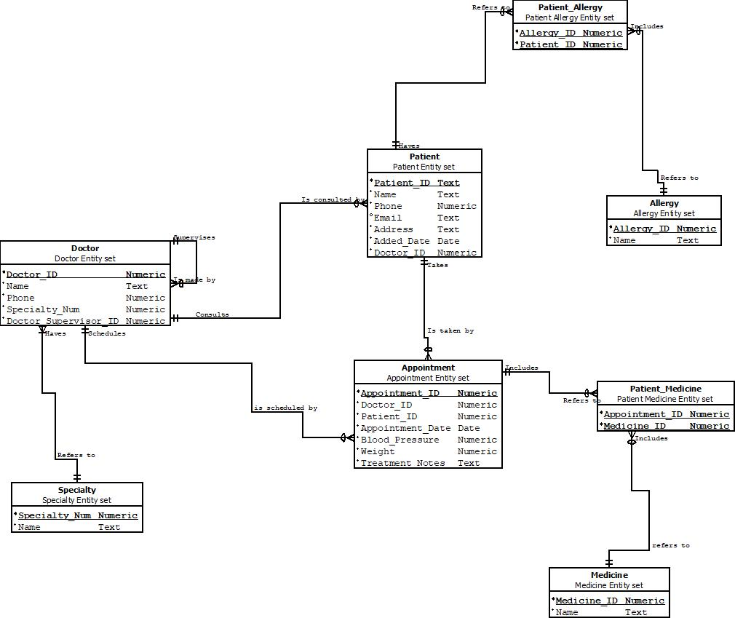

**Reference**

Shahbaz, Q. (2015, December 22). *Data Mapping for Data Warehouse Design* (1st ed.). Morgan Kaufmann. <https://doi.org/10.1016/C2015-0-04423-9>